**Assignment Brief – BTEC**

|  |  |  |  |  |  |
| --- | --- | --- | --- | --- | --- |
| **Programme** | | Level 3 Extended Diploma in Creative Media Production (Games Development) | | | |
| **Unit number(s) and title covered** | | Unit 73: Sound for Computer Games | | | |
| **Assignment number & title** | | Assignment Three: Creating and Implementing Sounds | | | |
| **Student name** | | *Lewis Hawkins* | | | |
| **Assessor** | | David Matravers | **Internal Verifier** | *James Shaun* | |
| **Date issued** | | *24.04.2019* | **Submission deadline** | *22.05.2019 at* ***4.30pm*** | |
| **Assessment Criteria** | **To achieve the criteria, the evidence must show that the student is able to:** | | | | **Assessor confirm met** |
| **P3** | Create sound assets for a computer game following industry practice, working within appropriate conventions and with some assistance | | | |  |
| **M3** | Create sound assets for a computer game working to a good technical standard following industry practice, showing some imagination and with only occasional assistance | | | |  |
| **D3** | Create sound assets for a computer game working to a technical quality that reflects near-professional standards following industry practice, showing creativity and flair and working independently to professional expectations | | | |  |
| **P4** | Apply sound assets to a computer game following industry practice, working within appropriate conventions and with some assistance. | | | |  |
| **M4** | Apply sound assets to a computer game working to a good technical standard following industry practice, showing some imagination and with only occasional assistance. | | | |  |
| **D4** | Apply sound assets to a computer game working to a technical quality that reflects near-professional standards following industry practice, showing creativity and flair and working independently to professional expectations | | | |  |

|  |  |  |  |  |  |  |  |
| --- | --- | --- | --- | --- | --- | --- | --- |
| **Assessor feedback - 1st submission** | | | | | | | |
|  | | | | | | | |
| **Did the learner meet the original deadline or agreed extension?** | | Yes ☐ No ☐ | | | | | |
| **Assessor signature** |  | | | | **Date** | |  |
| **Resubmission authorised?** | | Yes ☐ No ☐ | | | | | |
| **New agreed deadline date for submission** *\* must be within 10 days of receiving original assignment back* | |  | | | | | |
| **Lead Internal Verifier signature** |  | | | **Date** | |  | |
| **Assessor feedback - Resubmission** | | | | | | | |
|  | | | | | | | |
| **Assessor signature** (resubmission only) |  | | **Date** | | | |  |

|  |  |  |  |  |
| --- | --- | --- | --- | --- |
| **Scenario** | | | | |
| Now that you have finished your documentation on how to design and produce sound and the methods used to create sound you will now need to demonstrate your skills practically.  In this assignment you will be required to record sound, manipulate it and then implement the sounds into a game of your choice. | | | | |
| **Tasks and criteria covered – Task One (P3, M3, D3)** | | | | |
| In this task you are required to create sound assets to a near professional technical standard showing creativity and flair.  In this task you must be able to evidence the following **bold** headings with information in *italics* you may wish to write about.  When producing your document you should be evidencing how you have manipulated your sound and also explaining why you have chosen to create the sound in that way and what its purpose is within the game.   * **Plan**: *considerations, eg genre, sample rate, resolution, stereo or mono, processor effects, ambient sound, speech, voiceover; sound list, eg audio storyboard; asset management (file storage and retrieval, naming conventions); workflow (scheduling, efficient time management); deadlines (production milestones, deliverables, quality assurance)* * **Recording sound**: *recording log; recording (fieldwork, Foley effects, voiceovers, studio)* * **Audio levels and metering**: *meters, eg VU meter, peak program meter; standard operating level* * **Sound manipulation**: *editing, eg cut, copy, paste, trim, channel mixer, cue points, markers; effects, eg amplify, chorus, cross fade, delay, echo, fade in/out, invert, envelope, normalise, pan, reverb, reverse, resample, silence; time and pitch, eg Doppler, stretch; filters, eg pass (band, high, low), notch, noise reduction, pop/click, equalisation; layering; loops; cue list; play list; mix down*   Once you have written your document to explain how you have created your sounds you will then need to reflect on how the sounds came out and also your own production skills. Taking into account strengths, weaknesses and areas for improvement.   * **Industry practice**: *reflect on finished product (compared with original intentions, fitness for purpose, technical qualities); production skills (ideas generation, workflow and time management, technical competence, teamwork)* | | | | |
| **Tasks and criteria covered – Task Two (P4, M4, D4)** | | | | |
| Now that you have created and edited all of your sounds you will now be required to implement these into your game of choice.  In this task you must be able to evidence the following **bold** headings with information in *italics* you may wish to write about.  When writing about how you have implemented the sounds you should be writing about any issues that arose and how you had to fix them for example; background music being too loud so had to be turned down in the engine.   * **Asset management**: *importing; organising (file storage and retrieval, naming conventions)* * **Edit audio:** *audio library material, eg sound libraries, stock music assets; studio produced audio, eg Foley effects, voiceovers, fieldwork* * **Integrate audio**: *synchronising sounds, eg actions, on-screen movement, cut-scene; lip-synching* * **Audio production**: *mixing; rendering*   Now that you have implemented the sounds into your game you are required to write an evaluation reflecting on the overall product. In this evaluation you should take into consideration how the final sounds turned out in the game; their strengths, weaknesses and areas for improvement. You should also be reflecting on your own production skills and where these could have improved or where there were strengths.   * **Industry practice**: *reflect on finished product (compared with original intentions, fitness for purpose, technical qualities); production skills (ideas generation, workflow and time management, technical competence, teamwork)* | | | | |
| **Evidence you must produce for this task** | | | | |
| 10 fully edited final sound files in appropriate file format  Final game as a .exe with all sounds implemented  Portfolio evidencing all bold headings from task one and two. Including an evaluation for each task. | | | | |
| **Sources of information** | | | | |
| **Textbooks**  Baylis P, Freedman A, Procter N et al – BTEC Level 3 National Creative Media Production, Student Book  (Pearson, 2010) ISBN 978-1846906725  Baylis P, Freedman A, Procter N et al – BTEC Level 3 National Creative Media Production, Teaching Resource  Pack (Pearson, 2010) ISBN 978-1846907371  Brandon A – Audio for Games: Planning, Process, and Production (New Riders, 2004) ISBN 978-0735714137  Case A – Sound FX: Unlocking the Creative Potential of Recording Studio Effects (Focal Press, 2007)  ISBN 978-0240520322  Marks A – The Complete Guide to Game Audio: For Composers, Musicians, Sound Designers and Game  Developers, 2nd Edition (Focal Press, 2008) ISBN 978-0240810744  McCuskey M – Game Audio Programming (Course Technology, 2003)  Millward S – Fast Guide to Cubase SX (PC Publishing, 2005) ISBN 978-1870775984  Riley R – Audio Editing with Adobe Audition (PC Publishing, 2008) ISBN 978-1906005030  Sanger G et al – The Fat Man on Game Audio: Tasty Morsels of Sonic Goodness (New Riders, 2003)  ISBN 978-1592730094  **Websites**  www.audiosparx.com – online resource for digital audio  www.filmsound.org/game-audio – game audio articles  www.gamasutra.com – respected website for all things game development  www.gamecareerguide.com/features/696/adaptive_audio_a_beginners_guide_.php?page=1 – game audio  article making sounds for video games  www.gamedev.net – a forum, with good articles on all things game development and excellent game  developer resources  www.igda.org – non-profit-making industry body, useful for research and learning support | | | | |
| **Student checklist** | | | | **Complete?** |
| Proofread work | | | |  |
| Reference / Bibliography (if applicable) | | | |  |
| All pages attached and numbered – including introduction/conclusion/front sheet | | | |  |
| **Authenticity of Evidence Student declaration** | | | | |
| I certify that the evidence submitted for this assignment is my own.  I have clearly referenced any sources used in the work.  I understand that false declaration of authenticity (i.e. plagiarised work) is a form of academic misconduct and the relevant College procedures will be instigated if I am found to be in contravention of these. | | | | |
| **Student signature** |  | **Date of submission** | 22/05/19 | |
| **Re-authentication of Evidence Student declaration (for resubmission only)** | | | | |
| **Student signature** |  | **Date of resubmission** |  | |

NB. Students – the assignment starts on the first page **after** these front sheets, i.e. Page 1.

* For your convenience, page numbers have been inserted into the footer. **Please keep them**.
* You may choose to add a contents table (ToC) in this section.
* Please **do** **not use text boxes** for the main body of your written answers.
* Please make sure that images/screenshots are correctly formatted, laid out and labelled. A table of Figures (ToF) may also be added if you wish.
* Make sure you use Page (or Section) Breaks whenever a new page is required. (Rather than adding large numbers of Return/Paragraph characters.) Ensure that new Section breaks continue with correct orientation and correct page numbers.
* Ensure that you have referenced your work throughout, using references in text and that you also have a reference list and full bibliography at the end of the work according to the current **Harvard Referencing** conventions. **Failure to do so will make your work more difficult to authenticate.**
* **Plan**: *considerations, eg genre, sample rate, resolution, stereo or mono, processor effects, ambient sound, speech, voiceover; sound list, eg audio storyboard; asset management (file storage and retrieval, naming conventions); workflow (scheduling, efficient time management); deadlines (production milestones, deliverables, quality assurance)*
* **Recording sound**: *recording log; recording (fieldwork, Foley effects, voiceovers, studio)*
* **Audio levels and metering**: *meters, eg VU meter, peak program meter; standard operating level*
* **Sound manipulation**: *editing, eg cut, copy, paste, trim, channel mixer, cue points, markers; effects, eg amplify, chorus, cross fade, delay, echo, fade in/out, invert, envelope, normalise, pan, reverb, reverse, resample, silence; time and pitch, eg Doppler, stretch; filters, eg pass (band, high, low), notch, noise reduction, pop/click, equalisation; layering; loops; cue list; play list; mix down*

**Task One:**

**Plan:**

**Considerations:** For this assignment I need to consider what sound effects I need and why. The game is a sci-fi looter-shooter so it will require sound effects that allow the player to immerse themselves into the action, but also represent the source.

I will also have to take into consideration ethical and legal issues with the audio. The sounds will not include gory or offensive content and all effects were either created by me or used with permission, so there’ll be no legal issues.

**Sound List:**

In this game I will use:

Created by me (foley):

* 3 stone footsteps.
* 3 grass footsteps.
* 3 water footsteps.

Audio Library, but edited:

* Gunshots (2).
* The explosion.

Original Creation:

* Gunshots (2).

In total there’ll be 14 sound effects in the game.

**Asset Management:**

The sound effects will be stored in a file structure on my cloud storage. The file hierarchy is as follows.

Audio – Gunshots

Explosions

Footsteps – Stone

Water

Grass

The audio files will the be imported into Unity and organised in the same way.

The files will be exported into the needed file type. Gunshots, explosions, and footsteps will need to be an uncompressed file (.wav), but if I decide to add background music then that’ll have to be a lossy compressed file (.mp3).

The files will be named in the following way: Footstep_stone00, Footstep_stone01, etc.

**Recording Sound:**

**Recording:**

All foley effects will be recorded using a phone or other device and transferred onto my computer. There they’ll be edited in Audacity.

The footsteps will be foley and slightly edited to enhance the sound quality.

**Audio Levels and Metering:**

**Ambient Sound Checks:** Before recording I’ll check the db levels in the area around me. This will ensure the maximum quality of the recording.

**Sound Manipulation:**

**Editing:**

The sound effects will be edited in audacity. I’ll use different effects like normalise and click remover to enhance the effect, but for audio that’s too quiet I’ll use amplify.

The footsteps will likely need to be amplified and the gunshots might need to be edited further to make them sound more realistic.

**Reflection:**

**Finished product:**

The finished product is overall of good quality and I am happy with how each audio track came out.

**Issues:** There were a few problems with recording grass footsteps, because the recording software sees it as noise and removes it by default. I had to switch software to fix this issue.

**What would I change?** If I did this again I would create a music track for the background.

* **Asset management**: *importing; organising (file storage and retrieval, naming conventions)*
* **Edit audio:** *audio library material, eg sound libraries, stock music assets; studio produced audio, eg Foley effects, voiceovers, fieldwork*
* **Integrate audio**: *synchronising sounds, eg actions, on-screen movement, cut-scene; lip-synching*
* **Audio production**: *mixing; rendering*

**Task Two:**

**Asset Management:**

**Importing:** As stated in task one, each file will be imported as their chosen file type and organised in the same file structure.

**Edit Audio:**

Below is a sequence of how I edited the gunshots:

Importing audio tracks.

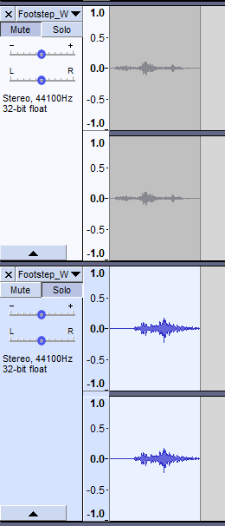

Amplifying the tracks.

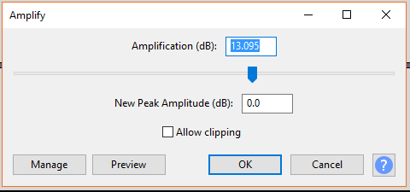

Using click removal.

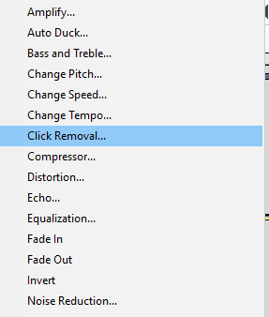

**Integrate Audio:**

Below is a sequence of how I implemented the audio effects:

Exporting the tracks.

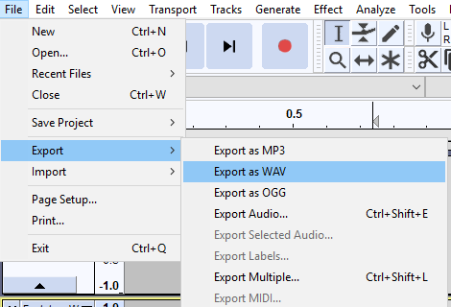

Creating the properties for the audio.

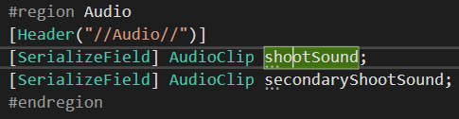

Writing the code to play the audio.

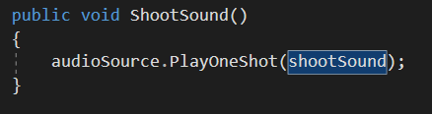

Setting-up the references in the Inspector.

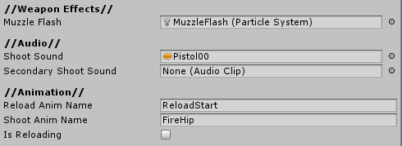

**Audio Production:**

Once the audio has been edited it’s exported into the appropriate file format.

**Reflection:**

**Finished product:**

I am very happy with how the final product came out and am satisfied with the overall quality.

**Issues:** The .exe failed to export due to an error. This was fixed with some quick research and the exe was exported successfully.

**What would I change?** If I did this again I would have spent more time on the wave mode and AI since there’re several bugs. One is during wave 3, 2 additional enemies spawn when the wave ends. I would also like the AI to be more dynamic and intelligent, along with lowering their accuracy. I like the audio tracks but I would like to include more ground types and play different footsteps when walking on them.